Assignment 5

Data Modeling Exercise Part1

1. Specify identifiers and attributes for the entities CD, ARTIST, ROLE, and SONG

Answer:

CD – Identifier: CD Name

Attributes: Based On, Book By, Music By, Lyrics By, Choreographed By, Produced By, Directed By

ARTIST – Identifier: CD Name

Attributes: Artist Name

ROLE – Identifier: CD Name

Attributes: Artist Name, Role Played

SONG – Identifier: CD Name

Attributes: Song Name, Sung By, Song Length

1. Construct a crow’s foot model showing relationships among these four entities. Name each relationship and specify cardinalities. Indicate which cardinalities you can justify on the basis of the CD cover and which you will need to check out with the users.

Answer:

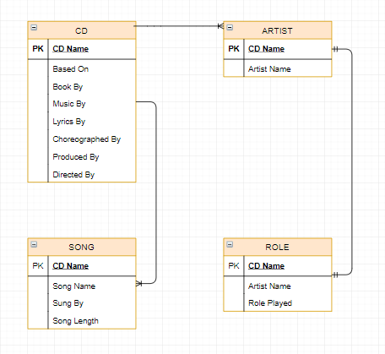

1. CD to ARTIST:

Relationship name: “Written”

Cardinality: 1: Many

1. ARTIST to ROLE

Relationship name: “Portrays”

Cardinality: 1:1

1. CD to SONG

Relationship Name: “Contains”

Cardinality: 1: Many

1. Consider a CD that does not involve a musical, so there is no need for ROLE. However, the entity SONG_WRITER is needed. Create a crow's foot model for CD, ARTIST, SONG, and SONG_WRITER. Assume that an ARTIST can either be a group or an individual. Assume that some artists record individually and as part of a group.

Answer:

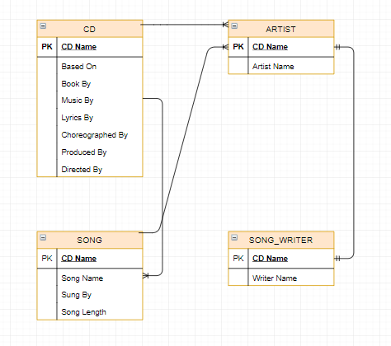

1. Combine the models you developed in your answers to B and C. Create new entities if necessary, but strive to keep your model as simple as possible. Specify identifiers and attributes of new entities, name new relationships, and indicate their cardinalities.

Answer:

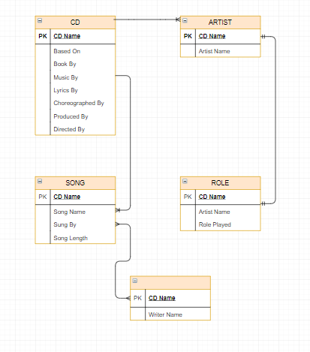

No new entity was added to the model, so all the relationships and cardinality stayed the same.

Data Modeling Exercise Part 2

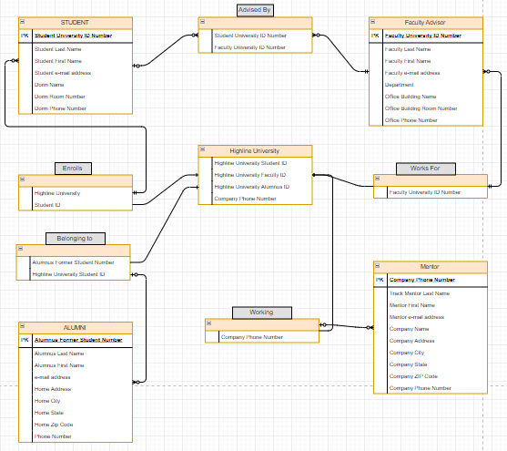

**Justification**:

STUDENT to FACULTY ADVISOR: Many : Many relationship, because we’re at a University where many students can be advised by many faculty members

STUDENT to HIGHLINE UNIVERSITY: Many: 1 relationship, because many students join Highline University

ALUMNI to HIGHLINE UNIVERSITY: Many: 1 relationship, because many alumni can be from Highline University.

FACULTY ADVISOR to HIGHLINE UNIVERSITY: Many: 1 relationship, because many faculty work for Highline University

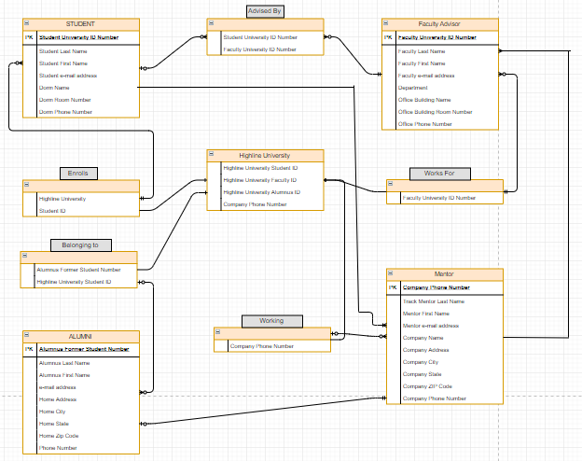



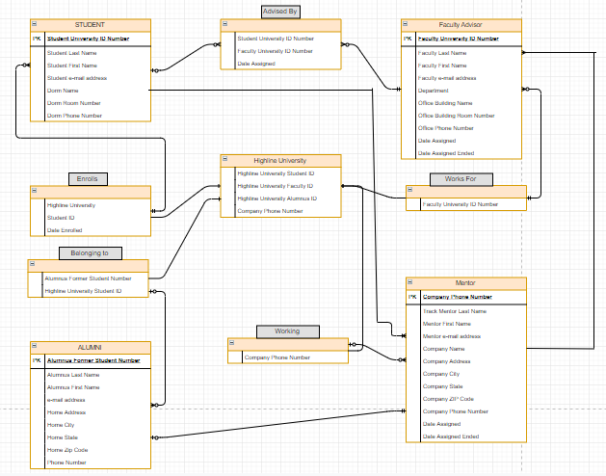

1. Data model B differs from data model A, because in B we have more relationships and able to suppress our data into a person instead looking at the data from an individual standpoint. Model C differs from Model B, because we were able to add more data to be recorded. New features included more relationships between the entities within the model and additional data as well.

Data Modeling Exercise Part 3

Two Tables: SHIPTMENT and ITEM

SHIPMENT (ShipmentNumber, Shipper, Phone, Contact, From, Departure, Arrival, Contents, InsuredValue)

ITEM (Item, Date, City, Store, Salesperson, Price)

**Multivalued Dependencies:**

SHIPMENT: No multivalued dependencies

ITEM:

City -> Store

(City, Store) -> Item

(City, Store) -> Salesperson

**Functional Dependencies:**

SHIPMENT:

ShipmentNumber -> Shipper

ShipmentNumber -> Phone

ShipmentNumber -> Contact

ShipmentNumber -> From

ShipmentNumber -> Departure

ShipmentNumber -> Arrival

ShipmentNumber -> Contents

Shipper -> Phone

Shipper -> Contact

ITEM:

(Item, Date, City, Store) -> Salesperson

(Item, Date, City, Store) -> Price

**Candidate Keys:**

SHIPMENT:

ShipmentNumber

ITEM:

(Item, Date, City, Store)

**Primary Keys:**

SHIPMENT:

ShipmentNumber

ITEM:

(Item, Date, City, Store)

**Foreign Keys:**

None in either table

2. How many different Contacts is there?
3. Can you buy from different stores in each city or country?
4. Can you buy the same items from different stores?
5. How many phones can a contact have?
6. Can you have the same city name in more than one country?
7. Can you buy items from different store?

SHIPMENT: No table can be created

ITEM:

CITY_STORE(City, Store)

2. A foreign key is supposed to be used to represent the same thing in both tables. In SHIPMENT the From attribute is the same as the City attribute in ITEM.
3. Data is inconsistent due to the first problem. In SHIPMENT it shows contents being shipped from a country but being purchased from a city, which can cause problems due to the data being inconsistent.
4. If we were to put ShipmentNumber into the ITEM table which will record which shipments contained the set of items purchased and will show the entire purchase being shipped on the same shipment.

ITEM (Item)

CITY_STORE (City, Store)

CITY_STORE_SALESPERSON (City, Store, Salesperson)

WHERE CITY_STORE_SALESPERSON.(City, Store) must exist in CITY_STORE.(City, Store)

CITY_STORE_ITEM (Item, City, Store)

WHERE CITY_STORE_ITEM.(City, Store) must exist in CITY_STORE.(City, Store) AND

WHERE CITY_STORE_ITEM.Item muste exist in ITEM.Item

ITEM_PURCHASED (Item, Date, City, Store, Salesperson, Price)

WHERE ITEM_PURCHASED.(Item, City, Store) must exist in CITY_STORE_ITEM.(Item, City, Store)

SHIPPER (Shipper, Phone, Contact)

SHIPMENT (ShipmentNumber, Shipper, From, Departure, Arrival, Contents, InsuredValue)

WHERE SHIPMENT.Shipper must exist in SHIPPER.Shipper

SHIPMENT_ITEM (ShipmentNumber, Item, Date, City, Store)

WHERE SHIPMENT_ITEM.ShipmentNumber must exist in SHIPMENT.ShipmentNumber AND

WHERE SHIPMENT_ITEM.(Item, Date, City, Store) must exist in ITEM_PURCHASE.(Item, Date, City, Store)



SHIPMENT (ShipmentNumber, Shipper, Phone, Contact, From, Departure, Arrival, Contents, InsuredValue)

SHIPMENT_ITEM (ShipmentNumber, Item, Date, City, Store, Salesperson, Price)

WHERE SHIPMENT_ITEM.ShipmentNumber must exist in SHIPMENT.ShipmentNumber AND

WHERE SHIPMENT_ITEM.(Item, City, Store) must exist in ITEM_CITY_STORE.(Item, City, Store)

ITEM_CITY_STORE (Item, City, Store, Salesperson)

1. There are no multivalue, multicolumn problems within the data

1. Yes there are inconsistencies in the data. I already discussed the data inconsistency with both country and city being stored as data without a foreign key present. Singapore is spelled wrong and given the shipment dates the Shipment numbers are reversed for International.
2. The database should have constraints so only correct data is being recorded
3. Verify Shipment numbers
4. Need to have a plan for storing City and Country data and how it will be used
5. Yes the arrival date for Shipment number 488955 is missing, so we need to verify if the shipment actually arrived and enter the date accordingly

1. Yes, the contents have multiple values in each shipment, which obscures data and prevent us from creating a foreign key. To deal with this problem we need to separate ITEM table to store item data and a SHIPMENT_ITEM table to store data of items in a shipment.